Serving the West Hartford community since 1931

Kingswood Oxford student teams with salon for Ronald McDonald House benefit

Published: Thursday, December 30, 2010

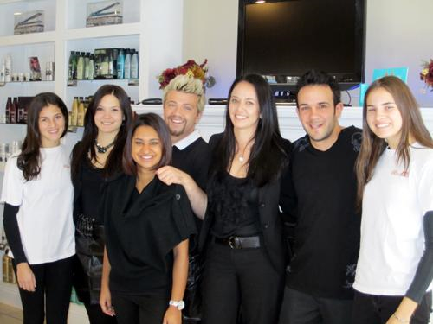
WEST HARTFORD – Kingswood Oxford School junior Sam Udolf of West Hartford joined forces with David Salon of Unionville last month to raise money for Ronald McDonald House, which provides a home away from home for seriously ill children and their families while the children receive medical treatment.
Salon owners Madeline and David Olivo opened their doors on a Sunday – when the shop is normally closed – and held a “Kerathon” – offering Keratin Complex Express Blowouts for $50, about $100 less than the usual fee. They also offered three raffle baskets of Keratin products and other hair care accessories, with raffle tickets selling for $5 each.
Udolf said that she knew the owners wanted to give back to the community in some way, so she suggested the fundraiser for Sam’s Race for a Place, an organization she founded in 2008 to support the Ronald McDonald House of Springfield.
With more than 40 people coming in for the treatments – Udolf estimates that about 30 were from the KO community – she and her salon partners raised more than $2,300. Udolf’s grandparents, Eleanor and Leonard Udolf, contributed another $2,300, further helping to make the event a success.
Sam’s Race for a Place – www.samsraceforaplace.com – links Udolf’s love of skiing and her desire to help others. Udolf, a member of KO’s interscholastic ski team who also participates in competitive ski racing outside of school, said she has raised more than $42,000 for her cause.
The salon fundraiser was just one more way to help her favorite charity. She said that during the past three years she has built a strong and emotional connection with the children who live there. “I have witnessed the children heal, become physically stronger and at the same time they have grown emotionally stronger during the healing process,” she said. “I have also grown as a person as I feel that I have taken a small role in their recovery.”
She added, “The children have enriched my life, and I have been fortunate to have developed some very strong relationships with them. It is this bond that keeps me coming back and trying to do more.”
Udolf said KO was a big part of the success of the salon event in more ways than attending on that November Sunday. Members of KO Cares, a school community service club led by Udolf, posted bright yellow fliers around campus to publicize the fundraiser. Students also made announcements at morning assemblies and presented a slideshow of the children at the Ronald McDonald House. “KO was a huge support in this,” Udolf said.
She added that she hopes people will think of the Ronald McDonald House when choosing an organization to support. “In the spirit of the holidays, if people are thinking of giving back, the Ronald McDonald House could really benefit,” she said.
Udolf said that through her fundraising events, public speaking and ski racing in Vermont in her speed suit – in the RMH colors of red, orange and white – she wants people to know about the house and the people who work to make it such a special place.
“I am happy to be a part of their effort,” she said. “At the end of the day, I am driven by the smiles on the children’s faces, and that is what keeps me coming back.”

